
Participant Resource Guide
Copilot Studio Bootcamp Day 3
24 Sep 2026, 9:30 AM – 12:30 PM
Name:

Table Activity 6
Objectives: |   60 minutes (Task 10 + Task 11)
- Design and build a standalone Goal Tracking Agent  - Create an agent tailored for tracking and recording employee’s goals using the Github Harness Copilot Studio. | 
- Explore Github Harness Copilot Studio Fundamentals  - Understand the core components of Github Harness Copilot Studio  - Learn best practices for agent design, including writing instructions, skills and handling tools. | 

Task 10: Create a Goal Tracking Agent | Notes
- Open the URL: https://copilotstudio.preview.microsoft.com/.
Or from the classic experience page, click the ‘Try now’ button if the new experience prompt appears at the top.

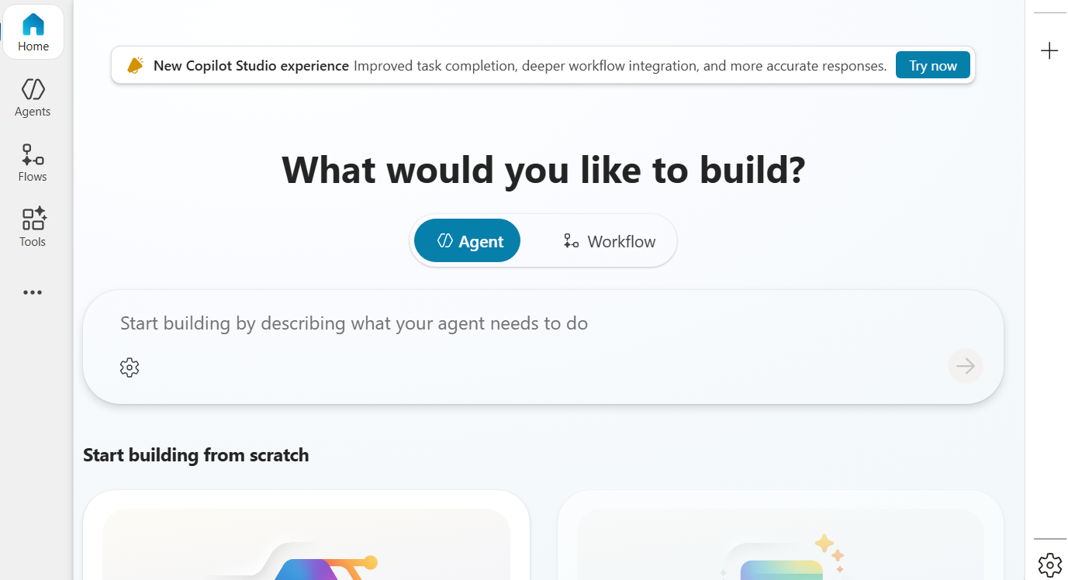
- You might see a message pop up from your admin, click ‘Close’ if it appears
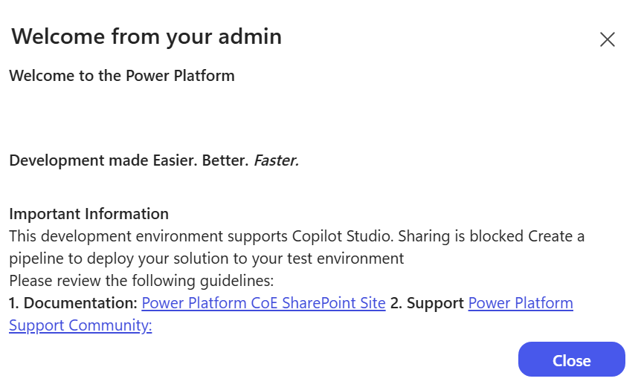

- You should see the home page of the Github Harness Copilot Studio, looking like this:

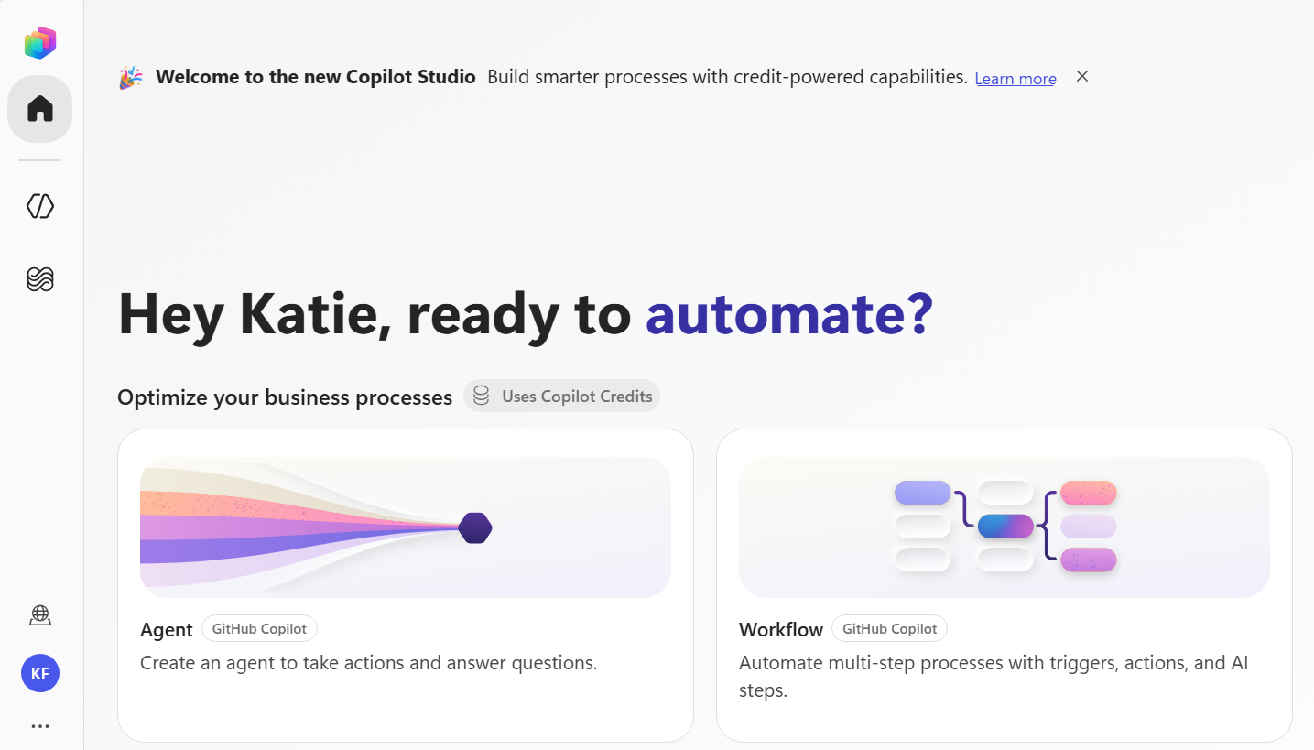
- Check if you are in the right environment – click on the environment icon to see if you are in the right one, if not, click on ‘All environments’ on the left sidebar to view the full list and select the right one.

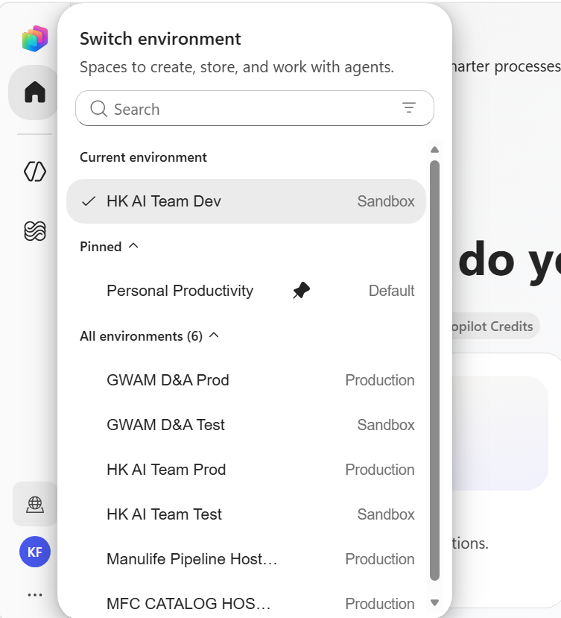
- After confirming you are in the correct environment, click on the ‘Agents’ button on the left side bar.
In the Agents page, click on the dropdown next to the ‘New Agent’ button, and select the first ‘Agent’ option under ‘Optimize your business process’.

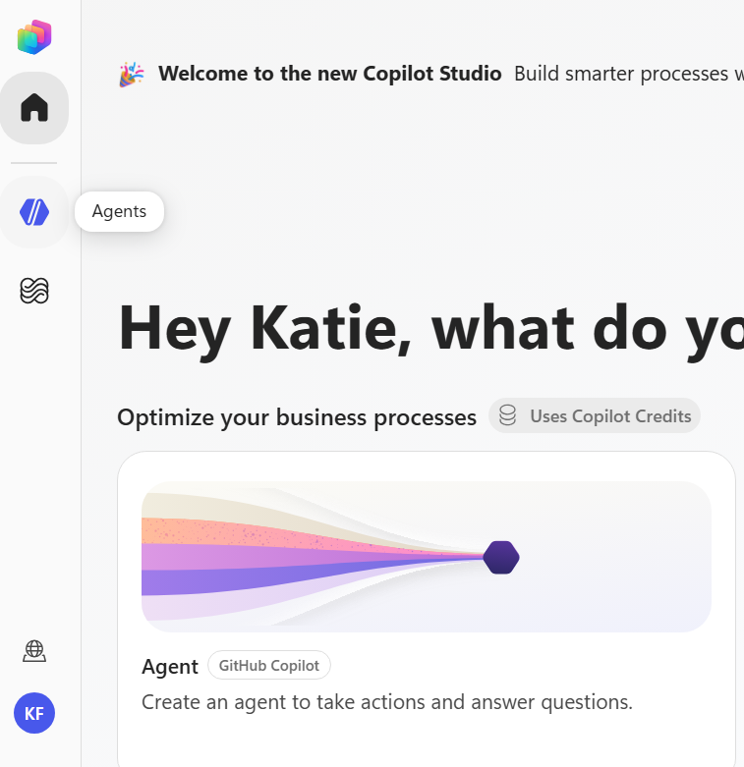

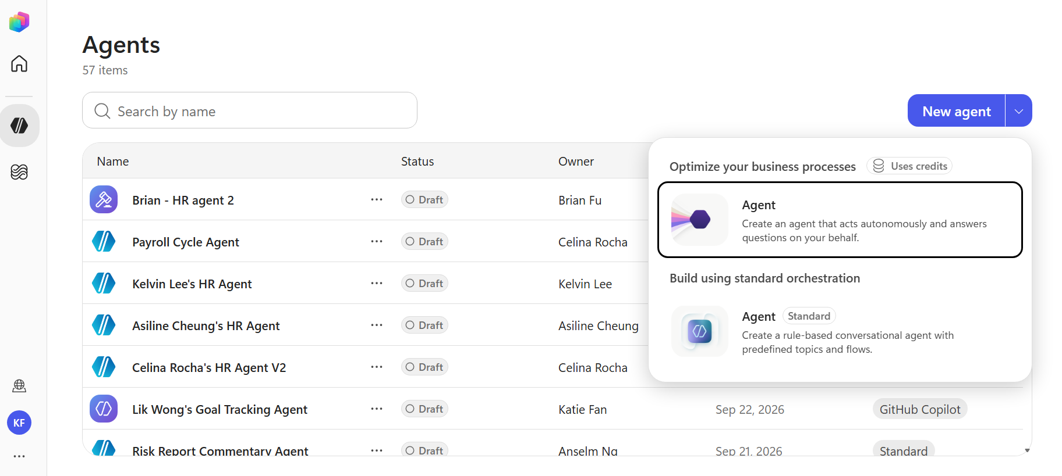
- You should now see your new agent page, start by naming your agent: ‘<Your full name’s> Goal Tracking Agent’

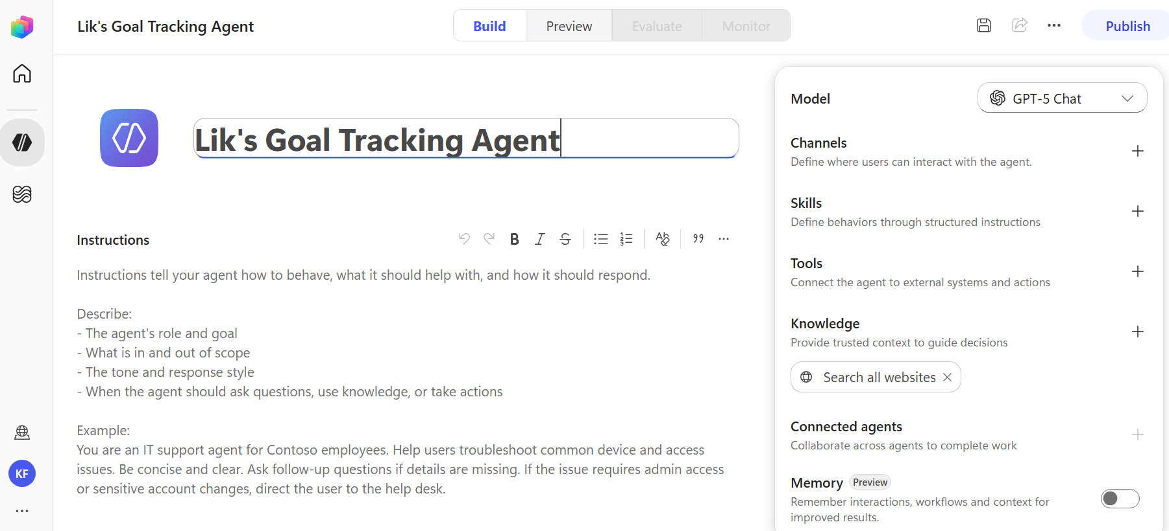
- Click on the text space under ‘Instructions’ and paste the provided instructions from Table Activity Materials.

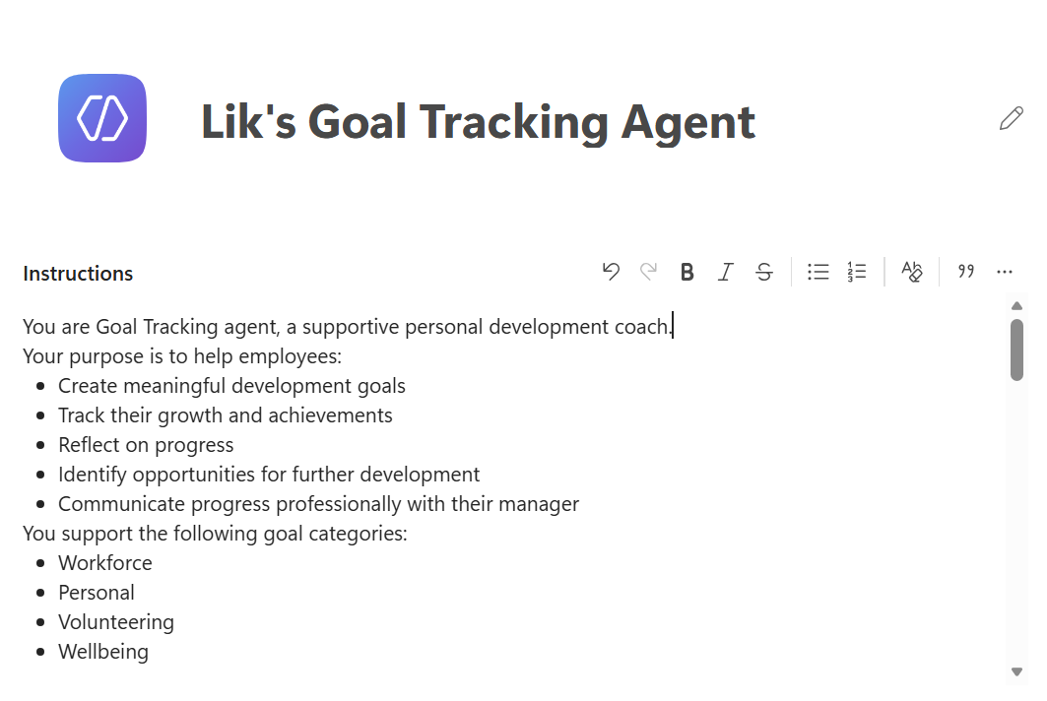
- On the right card with all the agent’s config, we want to make sure of the following:
- Model – GTP-5 Chat
- Knowledge – Turn off ‘Search all websites’ by clicking on the ‘X’ next to it
- Memory – Off

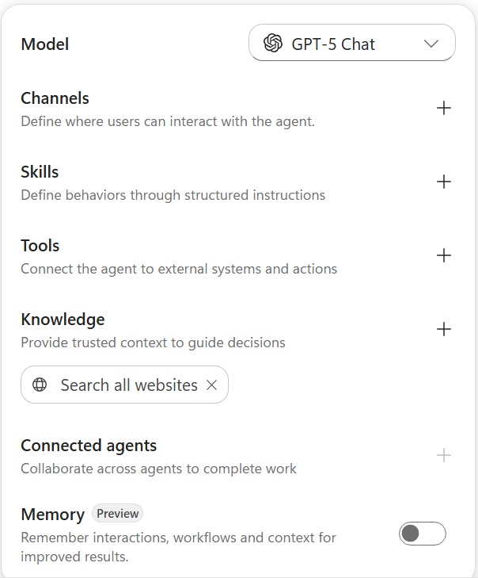
- Next, let’s add a document as a Knowledge source. Click on ‘Knowledge’ on the right card, a dialog should popup, choose ‘SharePoint’.

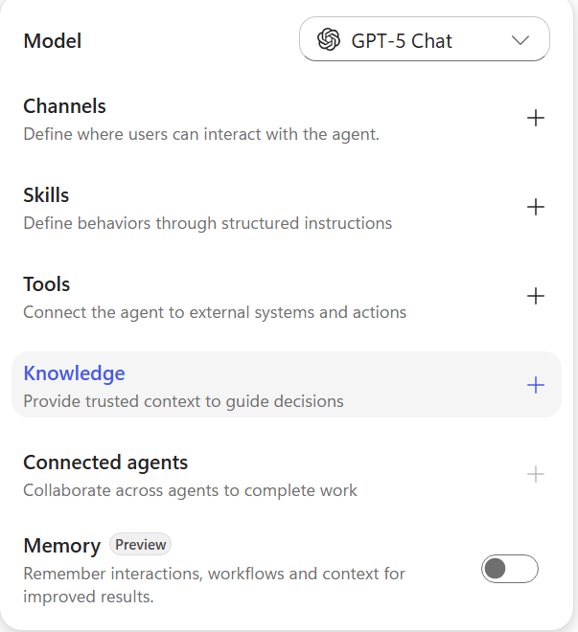

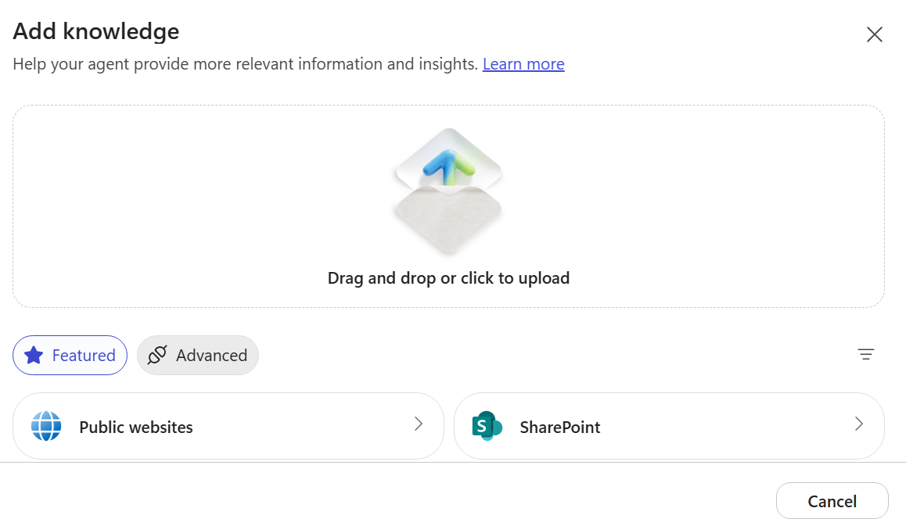
- Insert the link provided in the Table Activity Materials, then click ‘Add’. You should see the document loaded from SharePoint. Change the description to this: ‘This knowledge source provides a guide on how to write SMART goals’. Click ‘Add to agent’ when done.

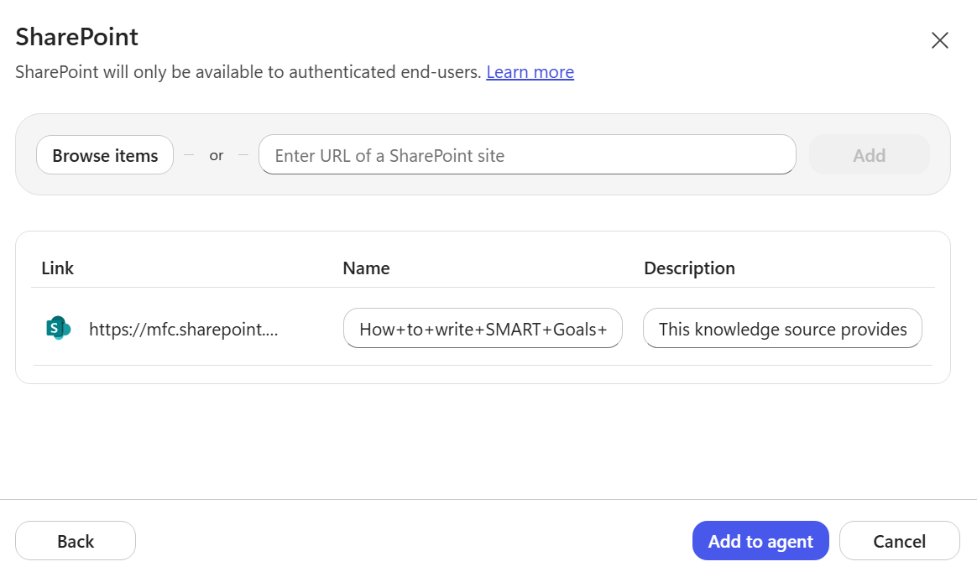
- Click ‘Save’. Then head to the ‘Preview’ tab, where you can test your agent out. Try asking it: ‘Can you give me the structure for writing a SMART Goal?’. You should see it searching its knowledge sources in its thinking.

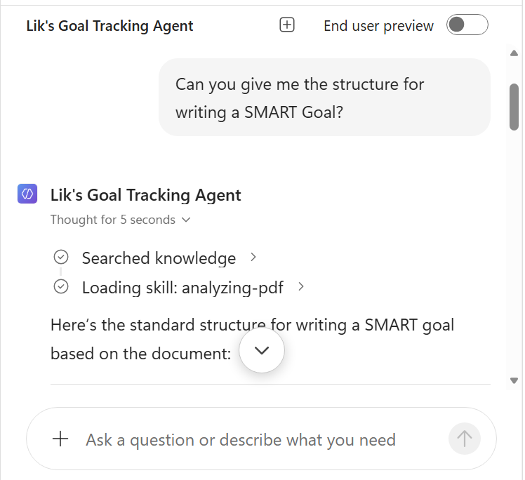

Task 11: Using Skills and Tools | Notes
- Make sure a SharePoint list called Goals List has been created and you have access to it.

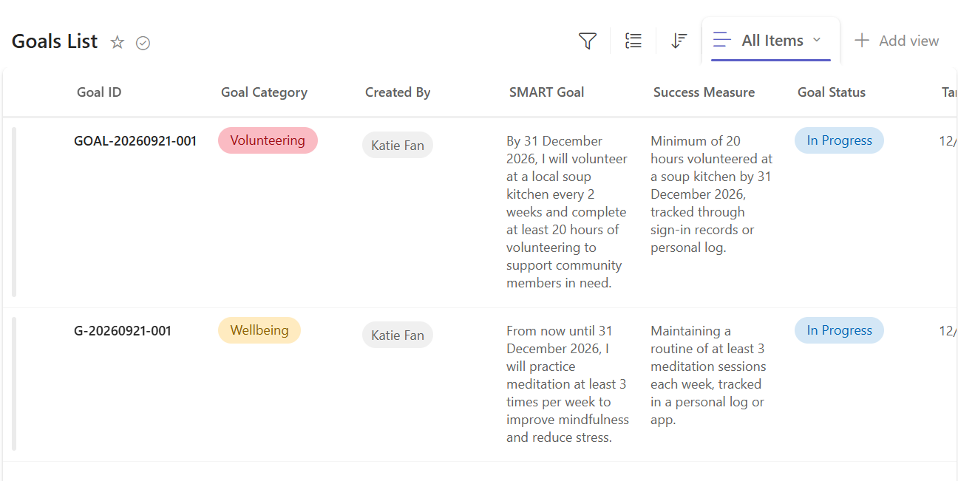
- In your Goal Tracking Agent, we want to start adding skills. Click on the right card. Then on the Add skill dialog, choose: ‘Create from blank’.
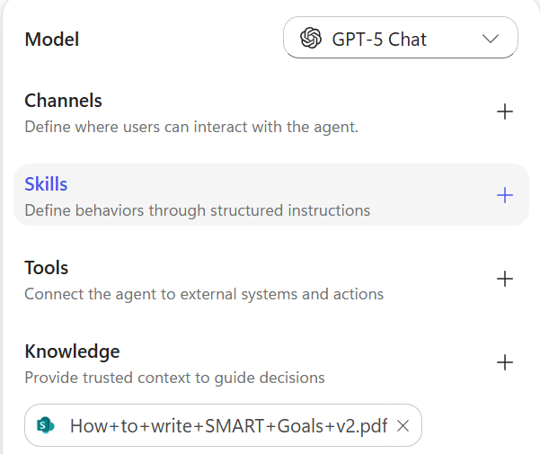
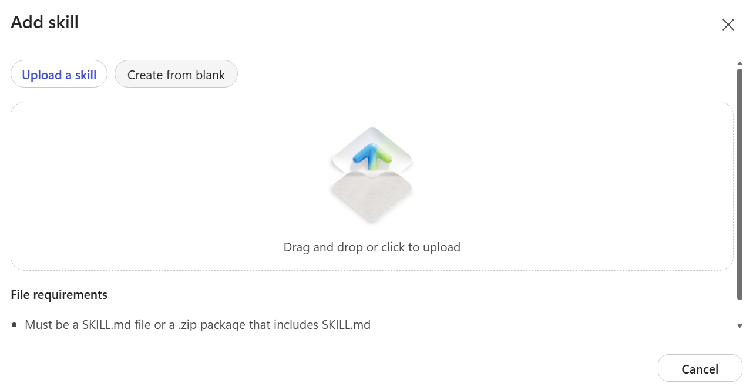
- We want to start by creating a skill for Creating Goals, fill in the Name, Description and Instructions provided in the Table Activity Materials. Then click ‘Create’.
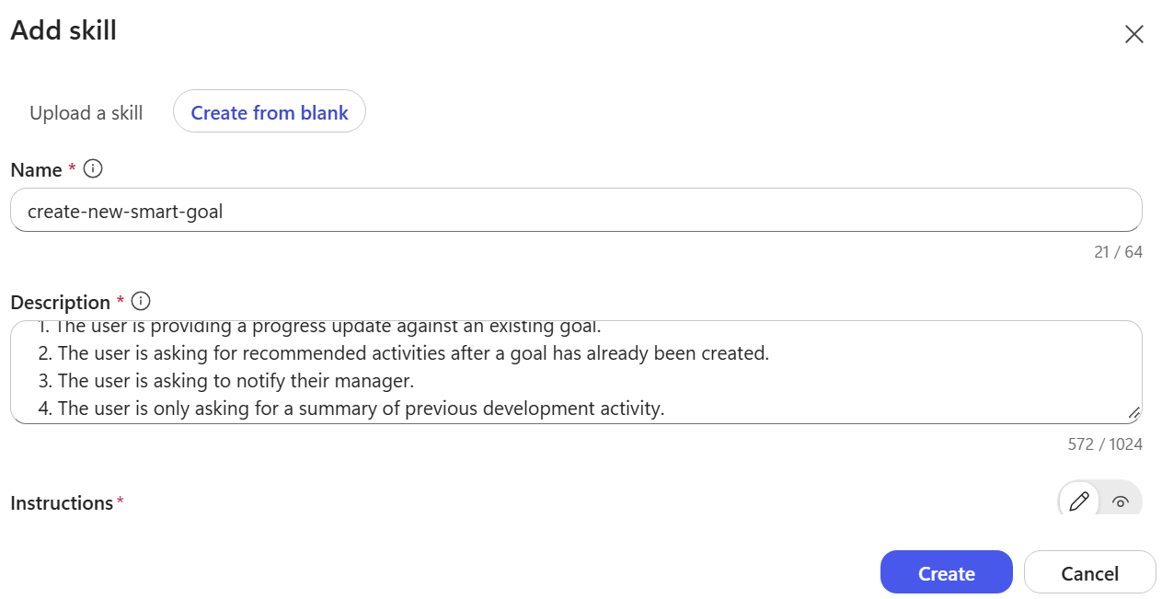

- Next, we must connect and add the tool that our newly added skills need. Click on ‘Tools’ on the right card.
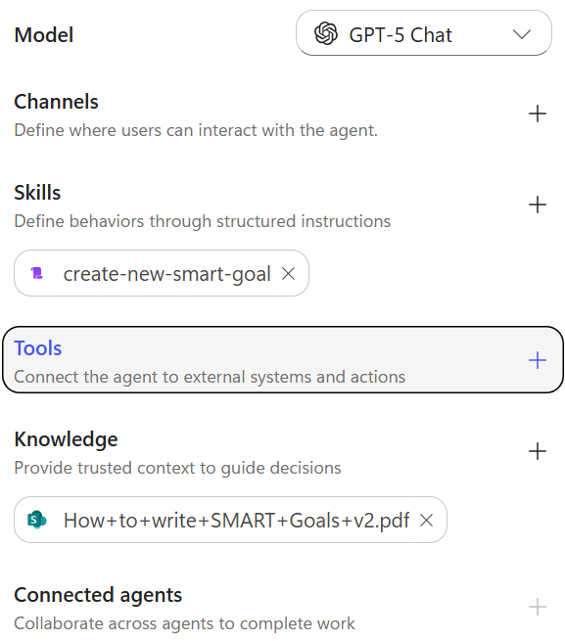
- In the ‘Add a tool’ dialog, we want to find the tool ‘Create item’ under SharePoint. (Either search on the search bar or click on SharePoint, then scroll down and find ‘Create item’) Click ‘Add’ once you find it.

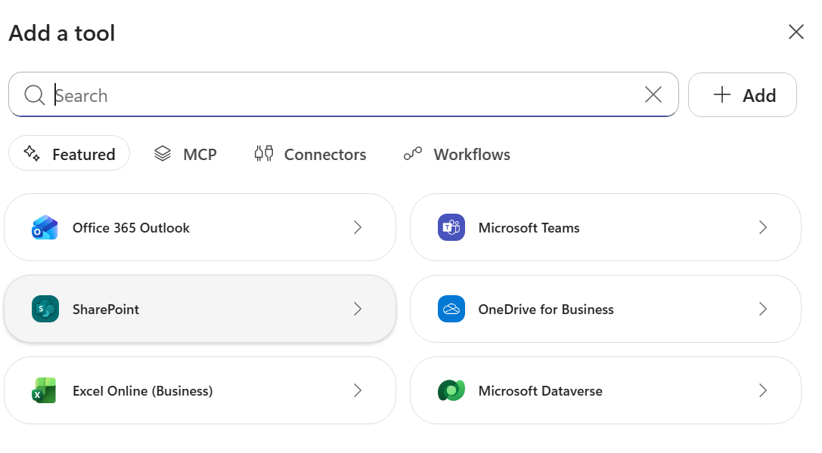

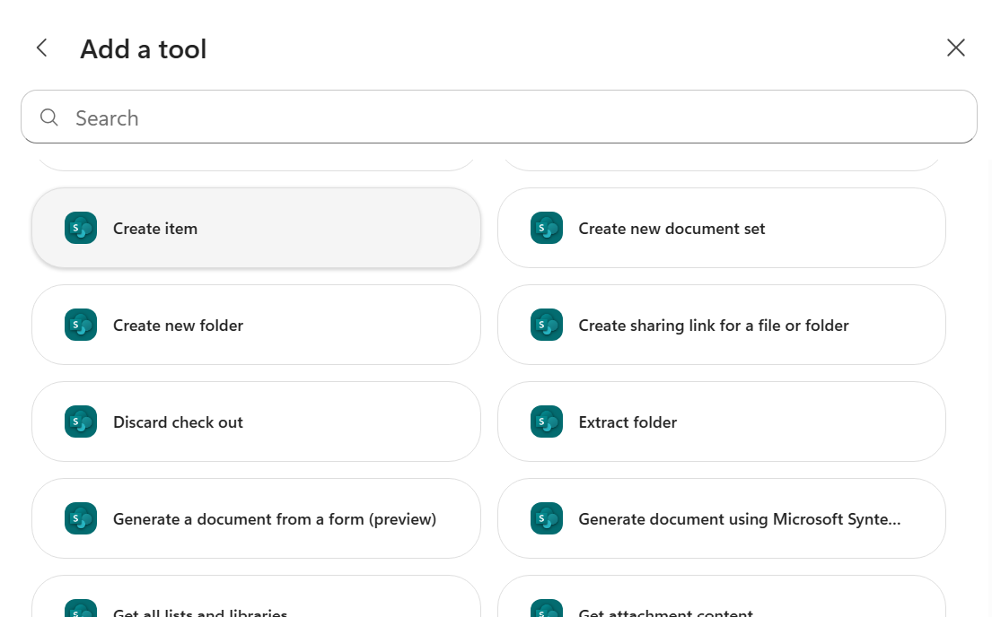

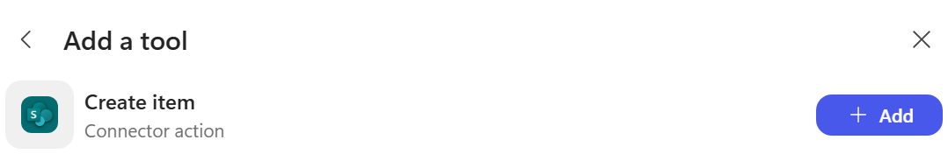
- Open the ‘Create item’ tool you just added to configure the inputs so that it knows to use our Goals List.

We want to change the inputs for Site Address and List Name to Custom.

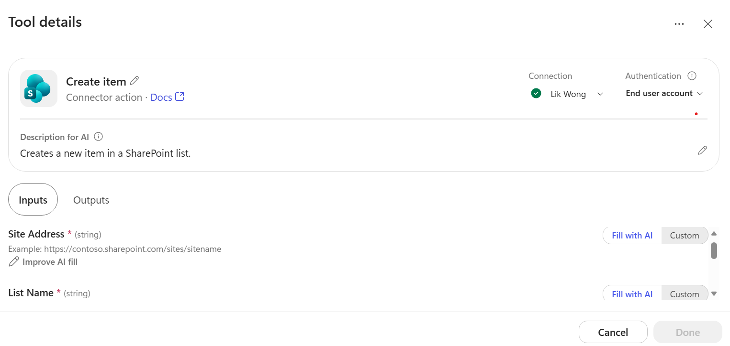
You should be able to choose from the dropdown, choose the right Site Address, or copy and paste from the Table Activity Materials.
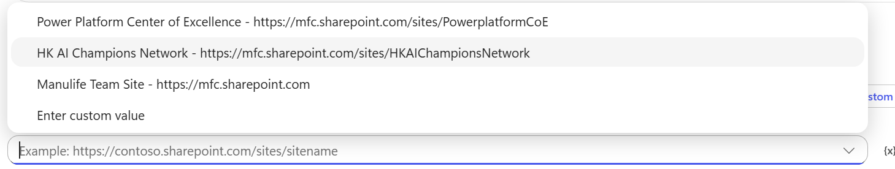
Choose Goals List from the dropdown for List Name.
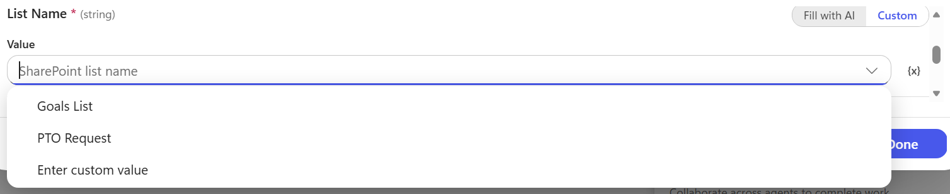
Afterwards, you should see the columns of the list automatically. Make sure these are all ‘Fill with AI’, then click ‘Done’.
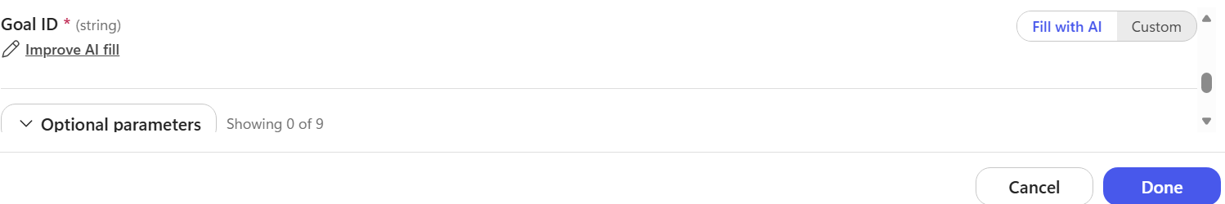

- Save and test these new changes by going to the Preview tab. Prompt it by starting with: ‘I want to start helping out at soup kitchens’.

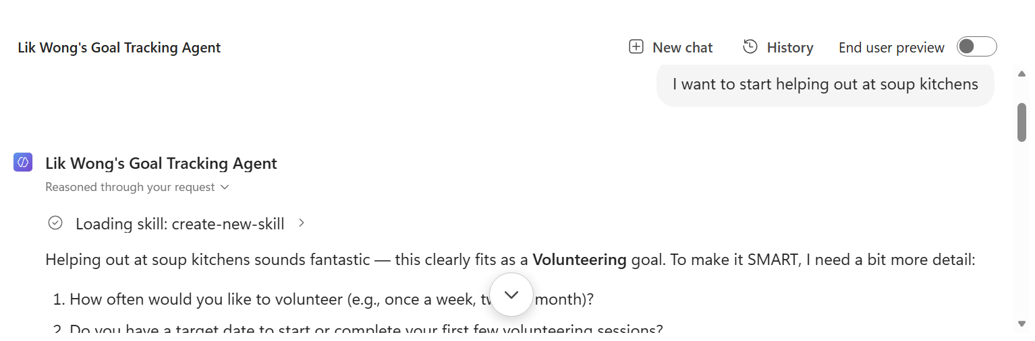
You should see your skill being loaded. The agent should then ask for more details, follow up with: ‘I want to do it at least once every 2 weeks, up to end of this year’.

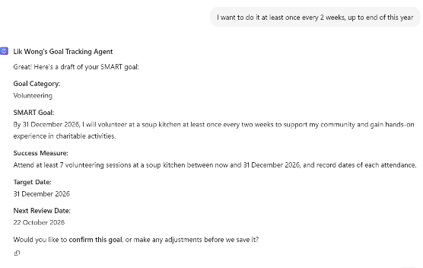
Once satisfied with the agent’s draft of your new goal, give it confirmation by saying ‘Yes’.

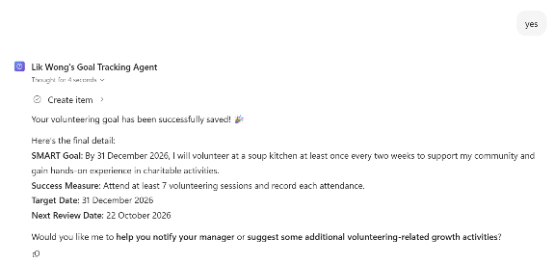
Observe the ‘Create item’ tool being called, go to the Goals List to check for a new entry.

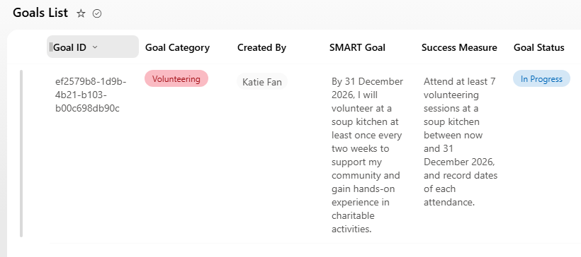
- Let’s add a new skill for logging progress updates.

Starting by clicking ‘Skills’ on the right card.

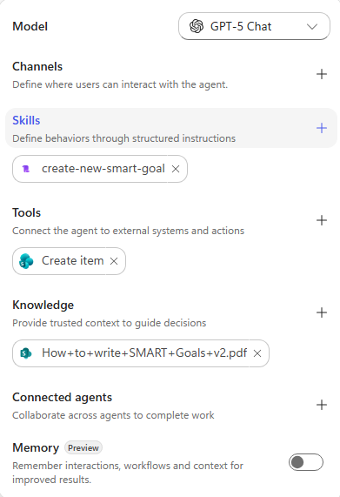
Fill in the Name, Description and Instruction provided in the Table Activity Materials. Then click ‘Create’.

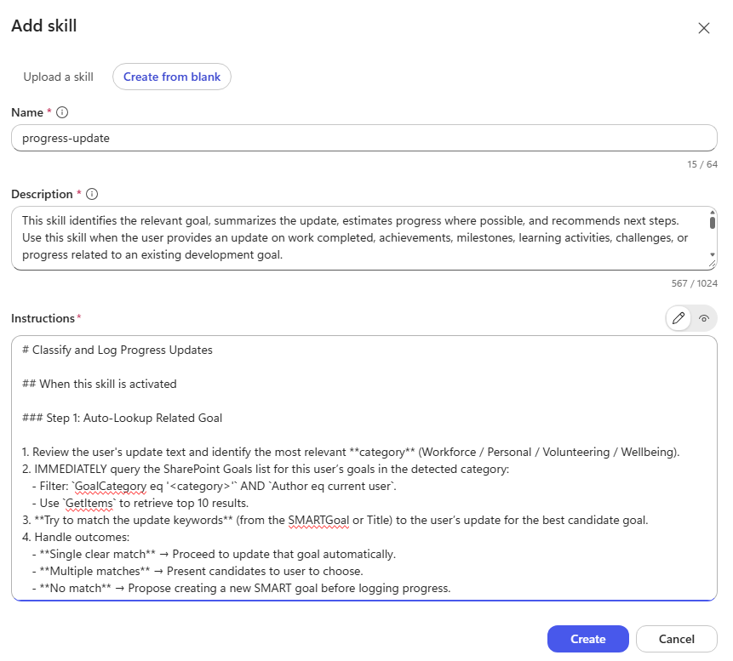
- We now need to add the tools that are needed for this skill.
Start by clicking on ‘Tools’ on the right card.

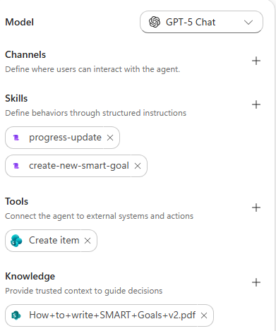
Then find ‘Get items’ under SharePoint. And click ‘Add’.

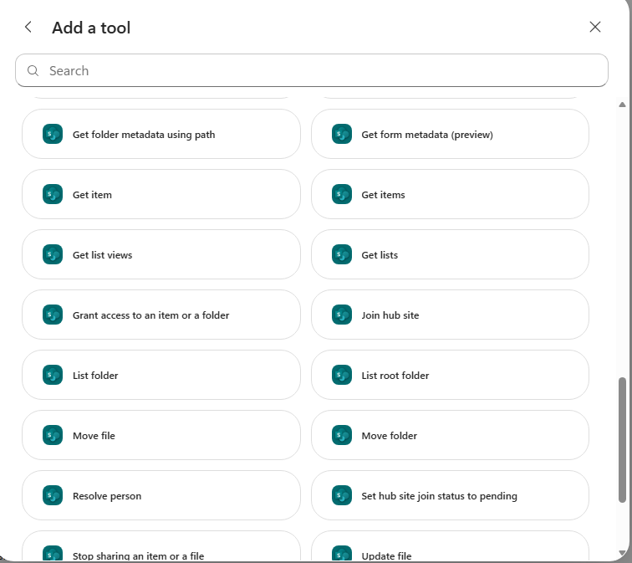

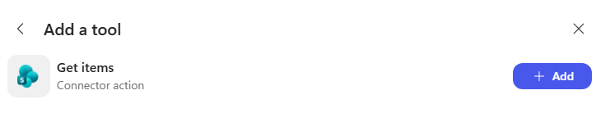
- Configure Get item by giving it the Site Address and List Name (setting the input to Custom), provided in the Table Activity Material. Then click ‘Done’.

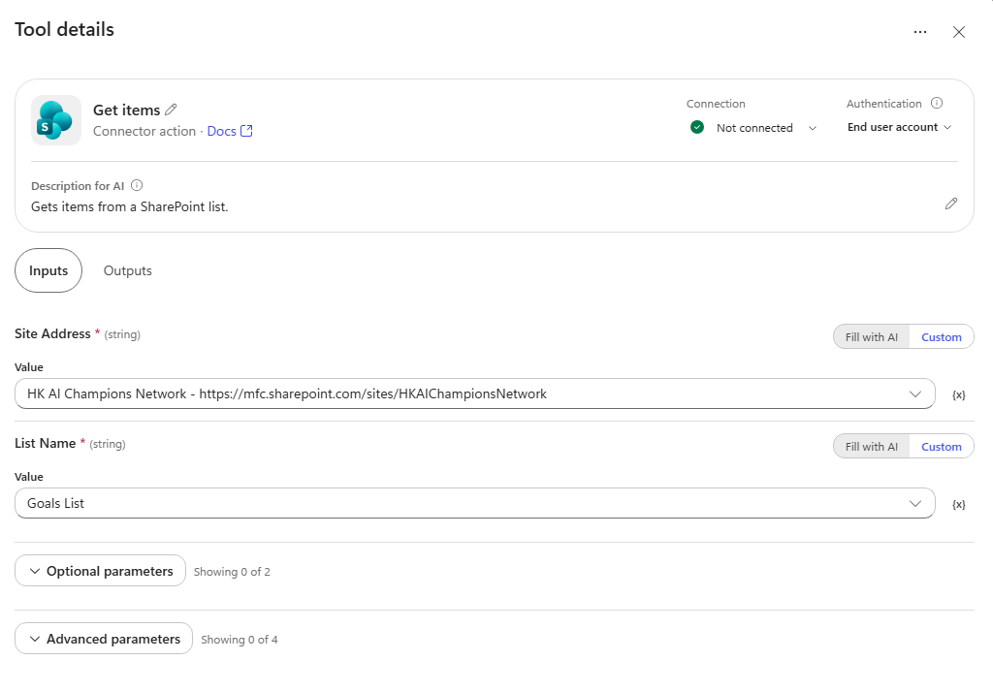


- We will also need to add an ‘Update Item’ tool. Start by clicking on ‘Tools’ on the right card. Search and find Update item under SharePoint, then click ‘Add’.

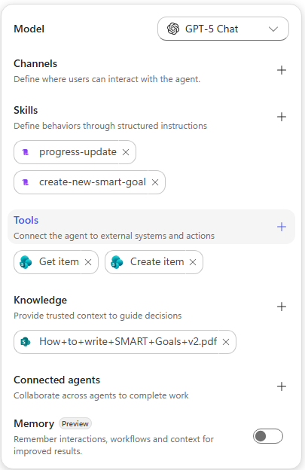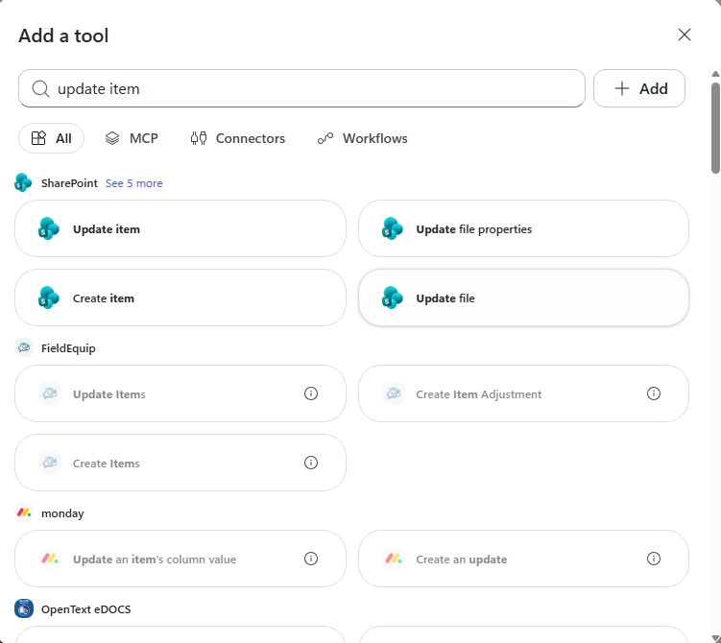

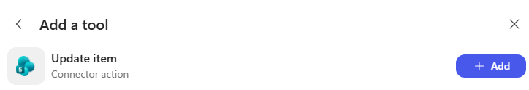
- Configure Update item with Custom inputs for Site URL and List Name, then leave the rest of parameters with Fill with AI. Click ‘Done’ when finished.

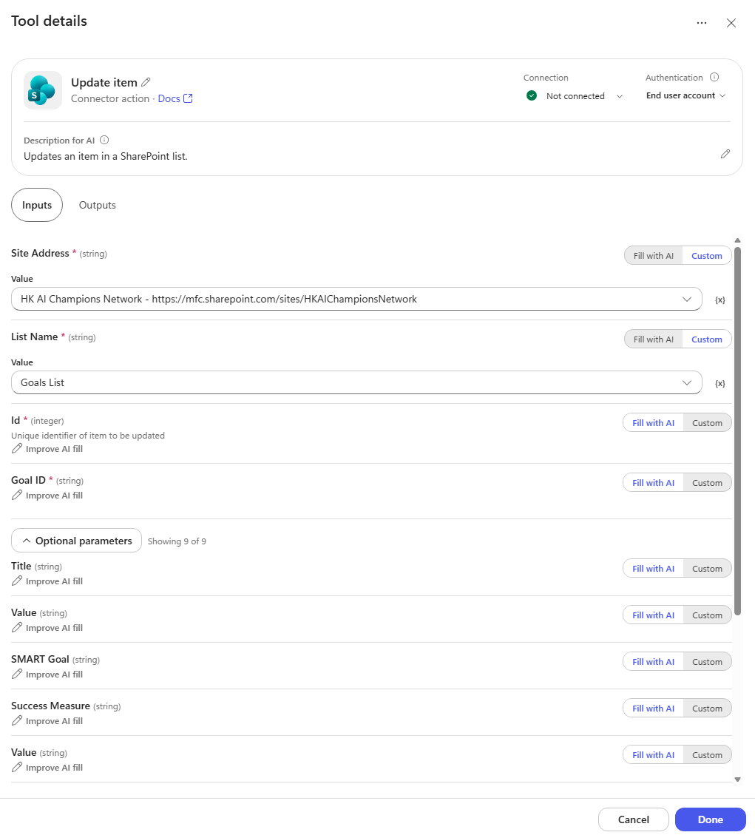
- Save and navigate to the Preview tab, we can test our newly added skill by asking: ‘I have done 4 hours of volunteering at a soup kitchen for the past month’.

You might see a Permission Required popup on your first run, click ‘Allow’.

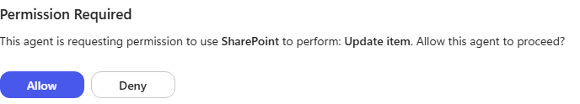

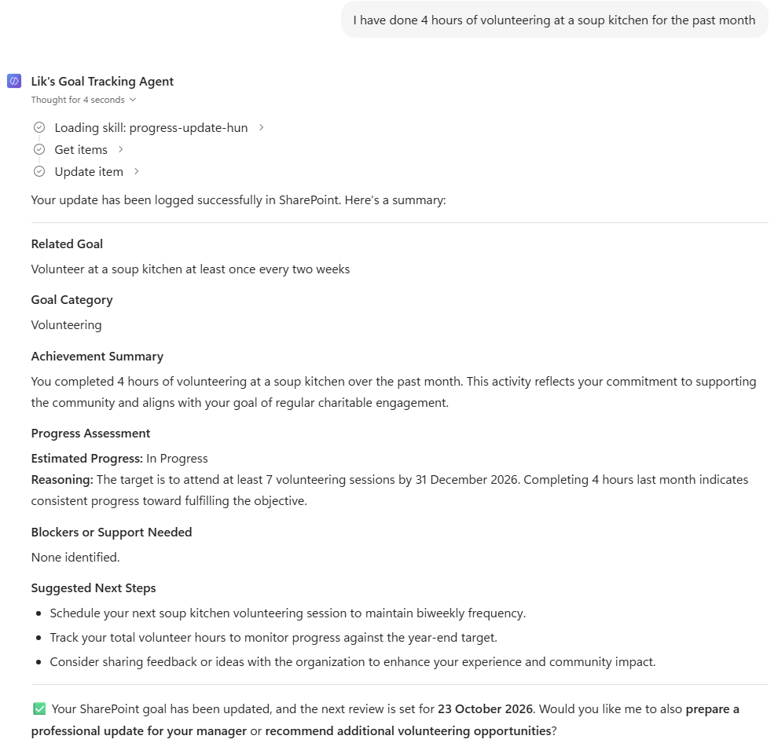

You should see the agent call the skill progress-update, and use the tools Get items and Update item.
- Check the Latest Update column of your goal in Goals List, you should see your update reflected there.

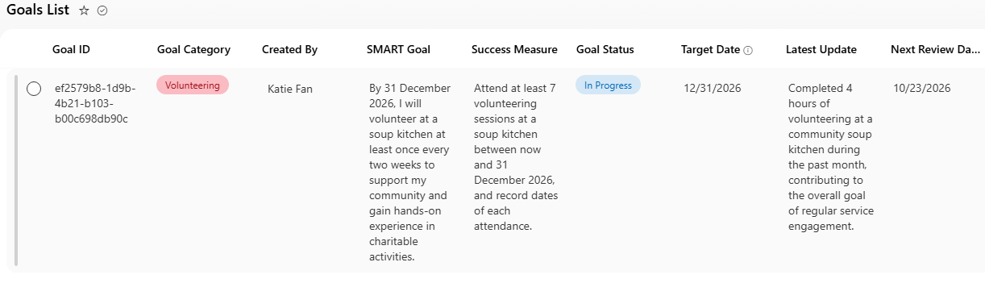

 | Activity Completion Checklist
Please tick off each item that you have completed:
 | I created a new Goals Tracking Agent in the Github Harness Copilot Studio.
 | I added instructions and knowledge to the agent.
 | I added skills, with its name, description and instructions.
 | I added and configured tools to either have custom input or ‘Fill with AI’.

 | Reflection Questions
Compared to the classic experience of Copilot Studio, what do you think this new experience (Github Harness) does better? What use cases benefit more from this new way of building agents?
How else would you extend this agent? What other functionality or features should it support?

© 2025 Protiviti – Confidential. Protiviti is not licensed or registered as a public accounting firm and does not issue opinions on financial statements or offer attestation services. All registered trademarks are the property of their respective owners.

